|  |  |  |  |
| --- | --- | --- | --- |
| SLNO | FIELDNAME | DATATYPE | DESCRIPTION |
| 1 | ADMIN_ID | NUMBER | Admin login id unique |
| 2 | USERNAME(EMAIL) | VARCHAR | Username of the theater owner and staff |
| 3 | PASSWORD | VARCHAR | Password |
| 4 | FIRST_NAME | VARCHAR | First name |
| 5 | LAST_NAME | VARCHAR | Last name |
| 6 | AGE | NUMBER | Age |
| 7 | CONTACT | NUMBER | Contact no |
| 8 | ADDRESS | VARCHAR | Address for communication |
| 9 | ADMIN TYPE | VARCHAR | Theater owner/staff |
| 10 | THEATER_ID | NUMBER | Theater id |

THEATER OWNER AND STAFF REG

PRIMARY KEY:ADMIN_ID

FOREIGN KEY: THEATER_ID

This table is used to register the details of the theater owners and staff members

USER REGISTERATION

|  |  |  |  |
| --- | --- | --- | --- |
| SLNO | FIELD NAME | DATA TYPE | DESCRIPTION |
| 1 | USER_ID | NUMBER | Userid od user |
| 2 | USERNAME(EMAIL) | VARCHAR | Username |
| 3 | PASSWORD | VARCHAR | Password |
| 4 | FIRSTNAME | VARCHAR | Firstname |
| 5 | LASTNAME | VARCHAR | Lastname |
| 6 | AGE | NUMBER | Age |
| 7 | SEX | VARCHAR | Gender |
| 8 | ADDRESS | VARCHAR | address |
| 9 | CONTACT | NUMBER | Contact no |

PRIMARY KEY: USER_ID

This table is used to register the details of the user

THEATER REG

PRIMARY KEY: THEATER ID

This table is handled by super Admin It is use to register the details of theater owners

|  |  |  |  |
| --- | --- | --- | --- |
| SLNO | FIELD NAME | DATA TYPE | DESCRIPTION |
| 1 | THEATER_ID | NUMBER | Theater id |
| 2 | THEATER_NAME | VARCHAR | Theatername |
| 3 | LOCATION | VARCHAR | Location of the theater |
| 4 | ADDRESS | VARCHAR | Address of the theater |
| 5 | CONTACT | NUMBER | Contact no of theater |
| 6 | EMAIL | VARCHAR | Email of the theater |

SCREEN DETAILS

PRIMARY KEY: SCREEN_ID

FOREIGN KEY: THEATER_ID comes from theater registeration

|  |  |  |  |
| --- | --- | --- | --- |
| SLNO | FIELD NAME | DATA TYPE | DESCRIPTION |
| 1 | SCREEN_ID | NUMBER | Screen id |
| 2 | THEATER_ID | NUMBER | Theaterid |
| 3 | THEATER_MODE | VARCHAR | Mode of theater whether 3k or 4k |
| 4 | NO_OF_SEAT | NUMBER | Total no of seats |

FOREIGN KEY: THEATER_ID

This table is used to register the details of theater

FILM REG

PRIMARY KEY: FILM_ID

This table is used to add film details it is handled by super admin

|  |  |  |  |
| --- | --- | --- | --- |
| SLNO | FIELD NAME | DATATYPE | DESCRIPTION |
| 1 | FILM_ID | NUMBER | Film id |
| 2 | FILM NAME | VARCHAR | Film name |
| 3 | ACTOR NAME | VARCHAR | Actor name |
| 4 | ACTRESS NAME | VARCHAR | Actress name |
| 5 | PRODUCER | VARCHAR | Producers name |
| 6 | SCRIPT WRITTER | VARCHAR | Script writer name |
| 7 | CATEGORY | VARCHAR | Category of name |

SHOW REG

PRIMARY KEY: SHOW_ID

FOREIGN KEY: SCREEN_ID comes from screen reg table

FOREIGN KEY: FILM_ID comes from film reg table

This table is register the show details to a theater it is done by the theater owner

|  |  |  |  |
| --- | --- | --- | --- |
| SLNO | FIELD NAME | DATATYPE | DESCRIPTION |
| 1 | SHOW_ID | NUMBER | Showid |
| 2 | SCREEN_ID | NUMBER | Screen id |
| 3 | FILM_ID | NUMBER | Film id |
| 4 | SHOW TIME | VARCHAR | Show times |

FOOD REG

PRIMARY KEY: FOOD_ID

This table is used to register the food details

|  |  |  |  |
| --- | --- | --- | --- |
| SLNO | FIELDNAME | DATA TYPE | DESCRIPTION |
| 1 | FOOD_ID | NUMBER | Foodid |
| 2 | FOOD NAME | VARCHAR | Foodname |
| 3 | CATEGORY | VARCHAR | Category of food |
| 4 | PRICE | NUMBER | Price of food |
| 5 | TAX | NUMBER | Tax rate |
| 6 | STATUS | NUMBER | Available or not |

SHOW FOOD REG

PRIMARY KEY: SFOOD_ID

FOREIGN KEY: SHOW_ID

FOREIGN KEY: FOOD_ID

This table is used to register the food for the show

|  |  |  |  |
| --- | --- | --- | --- |
| SLNO | FIELD NAME | DATA TYPE | DESCRIPTION |
| 1 | SFOOD_ID | NUMBER | Showfoodid |
| 2 | SHOW_ID | NUMBER | Show id |
| 3 | FOOD_ID | NUMBER | Food id |
| 4 | QUANTITY | NUMBER | No of quantity need |

SEAT REG

PRIMARY KEY: SEAT_ID

FOREIGN KEY: SCREEN_ID

This table is used to add the details about the seat

|  |  |  |  |
| --- | --- | --- | --- |
| SLNO | FIELD NAME | DATA TYPE | DESCRIPTION |
| 1 | SEAT_ID | NUMBER | Seat id |
| 2 | SCREEN_ID | NUMBER | Screen id |
| 3 | SEAT NAME | VARCHAR | Seat name |
| 4 | ROW_NAME | VARCHAR | Row name |
| 5 | COLUMN_NAME | VARCHAR | Column name |
| 6 | STATUS(GOOD OR repair) | VARCHAR | Status of seat whether good /repair |

SHOW BOOKING

PRIMARY KEY: BOOKING_ID

FOREIGN KEY: SEAT_ID

FOREIGN KEY: SHOW_ID

FOREIGN KEY: USER_ID

This table is used to book the show this is done by user

|  |  |  |  |
| --- | --- | --- | --- |
| SLNO | FIELD NAME | DATATYPE | DESCRIPTION |
| 1 | BOOKING_ID | NUMBER | Booking id |
| 2 | SEAT_ID | NUMBER | Seat id |
| 3 | SHOW_ID | NUMBER | Show id |
| 4 | STATUS | NUMBER | Status |
| 5 | USERID | NUMBER | Userid |

FOOD BOOKING

|  |  |  |  |
| --- | --- | --- | --- |
| SLNO | FIELD NAME | DATATYPE | DESCRIPTION |
| 1 | FOOD_BOOKING_id |  | Foodbookingid |
| 2 | FOOD_ID |  | Food id |
| 3 | BOOKING_ID |  | Booking id |

BANK DETAILS

PRIMARY KEY: BANK_ID

FOREIGN KEY:

This table contain the details of the the bank

|  |  |  |  |
| --- | --- | --- | --- |
| SLNO | FIELD NAME | DATA TYPE | DESCRIPTION |
| 1 | BANK_ID | NUMBER | BANK ID |
| 2 | BANK NAME | VARCHAR | BANK NAME |
| 3 | IFSC CODE | VARCHAR | IFSC CODE OF THE BANK |
| 4 | BRANCH NAME | NUMBER | BRANCH NAME OF THE OFFICE |

TRANSACTION DETAILS

PRIMARY KEY: TRANS_ID

FOREIGN KEY: BANK_ID

FOREIGN KEY: USER_ID

|  |  |  |  |
| --- | --- | --- | --- |
| SLNO | FIELDNAME | DATATYPE | DESCRIPTION |
| 1 | TRANS_ID | NUMBER(20) | TRANSACTION ID OF EACH TRANSACTION |
| 2 | BANKID | NUMBER (10) | BANKI ID |
| 3 | USER_ID | NUMBER(20) | CUSTOMER ID |
| 4 | ACC_NO | NUMBER(30) | ACCOUNT NO OF THE CUSTOMER |
| 5 | CARD_NO | NUMBER(30) | CREDIT CARD NO/DEBIT CARD NO |
| 6 | TAMOUNT | NUMBER(10) | TOTAL CASH IN BANK |

FEEDBACK TABLE

PRIMARY KEY: FED_ID

FOREIGN KEY: USER_ID

This table is used to enter the feedback it is used by customer

|  |  |  |  |
| --- | --- | --- | --- |
| SLNO | FIELDNAME | DATATYPE | DESCRIPTION |
| 1 | FEED_ID | NUMBER(10) | FEEDBACK ID |
| 2 | USER_ID | VARCHAR(40) | EMAIL ID OF THE CUSTOMER |
| 3 | REASON | VARCHAR(1000) | REASON |

FORM DESIGN

LOGIN

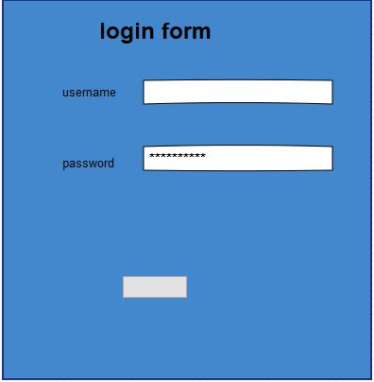

THEATER OWNER REG

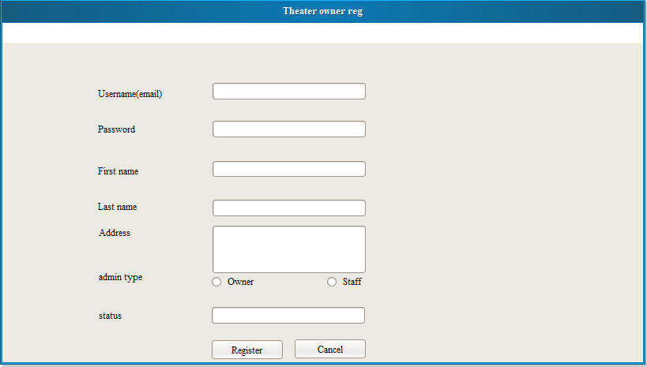

SHOW BOOKING

